LOAD BALANER
Topic Create an instance ,install apache2 sever and deploying apache2 with Load Balancer

Create instance and install apache2 and index.html file
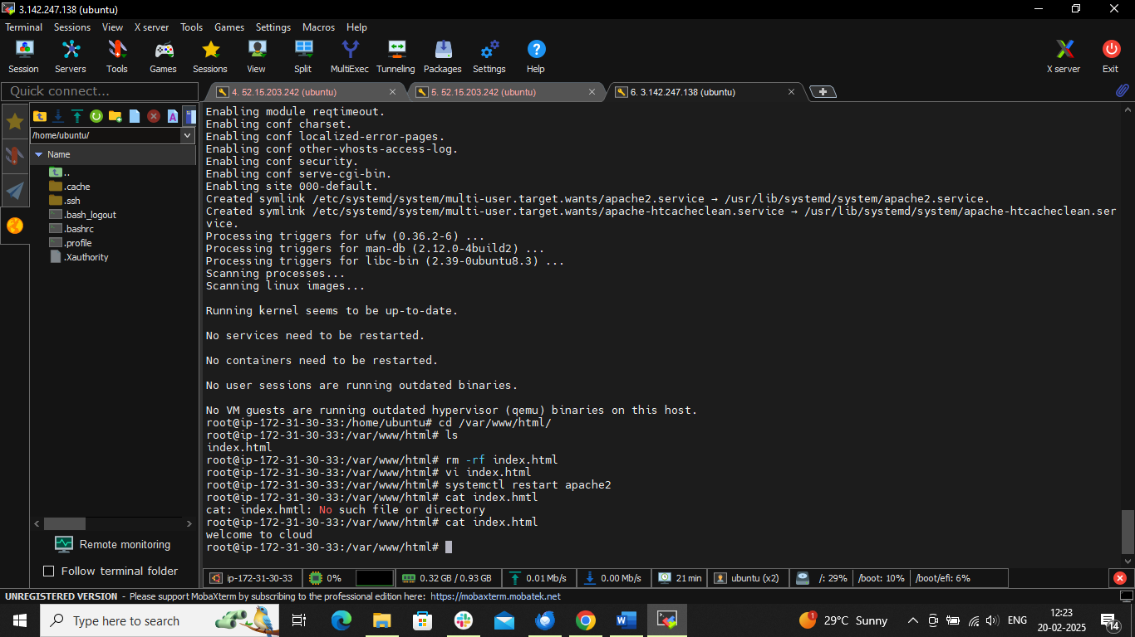

Create Load balancer
Ec2 dashboard left side load balancer Follow steps
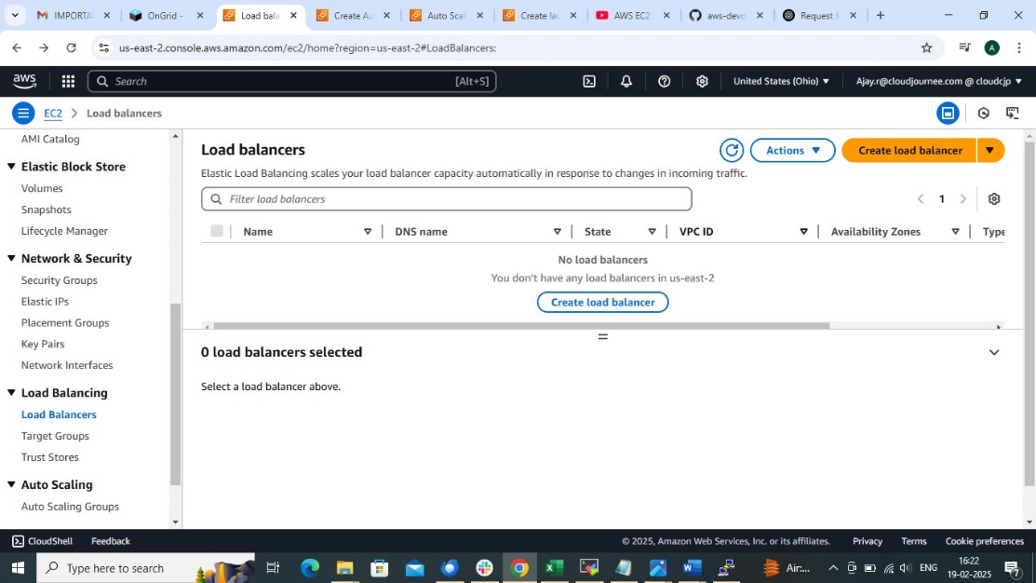

Write name of LB and choose internet facing scheme
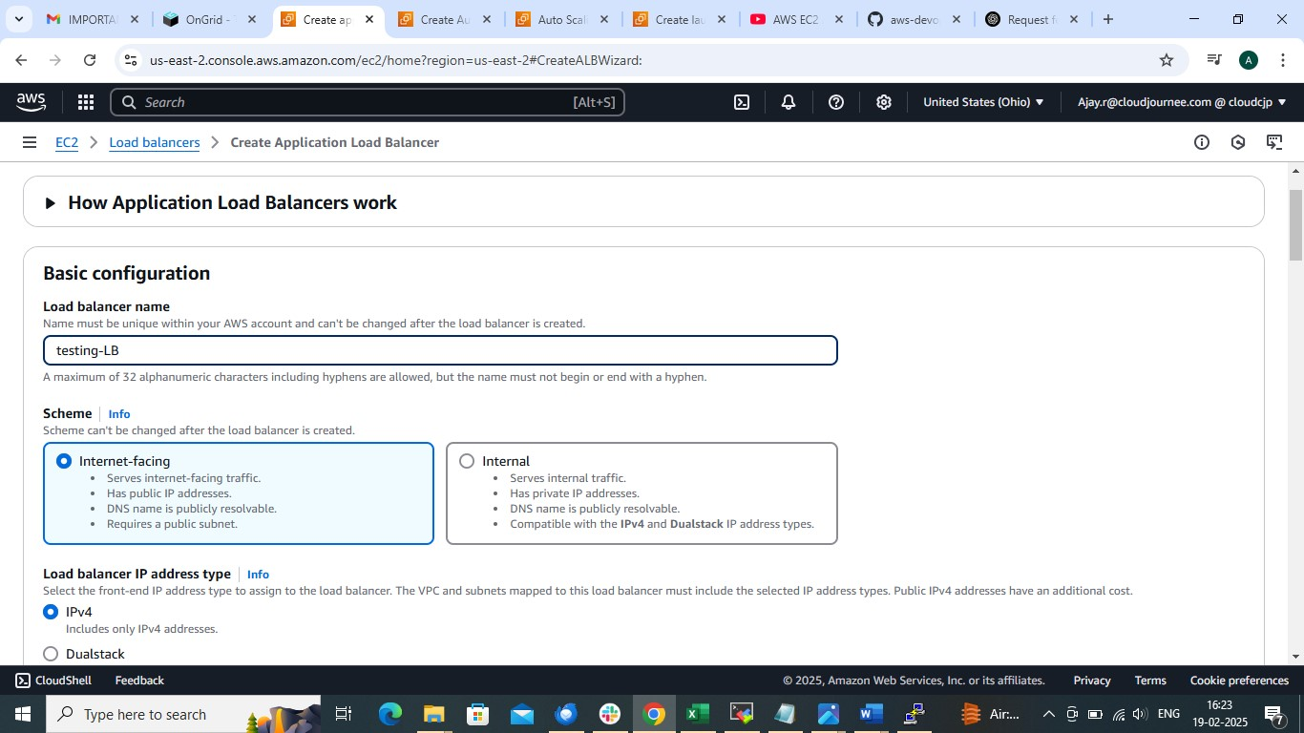

Choose VPC and Subnets If you haven’t created then CHOOSE DEFAULT ONE

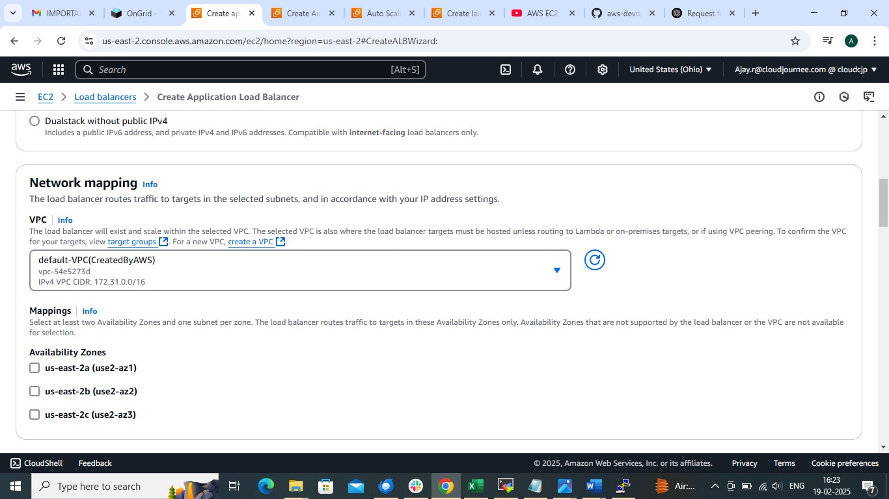

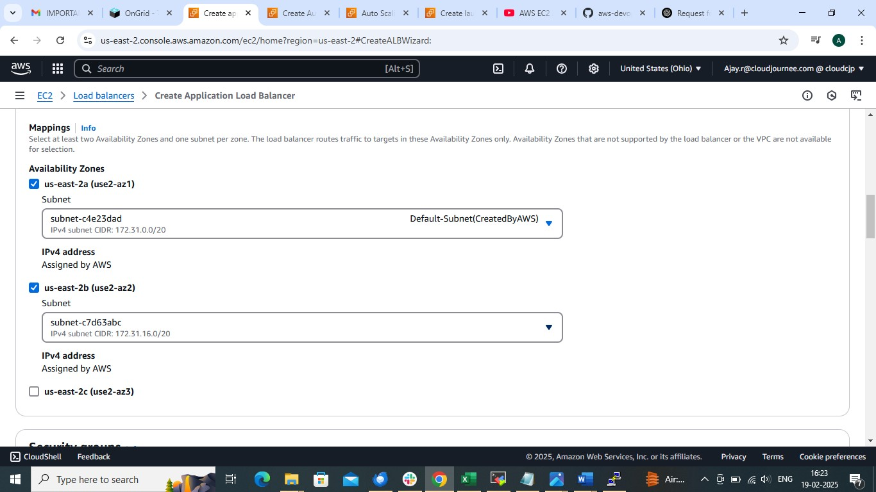

Create security group allowing permission HTTP
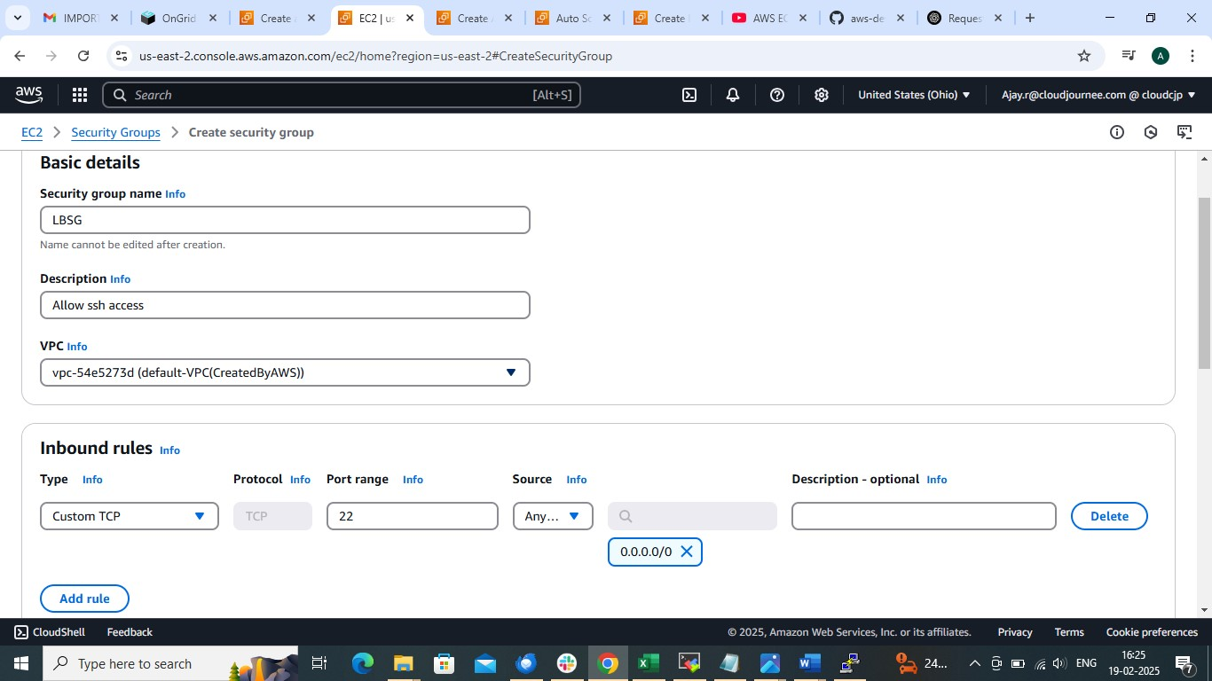

Choose SG

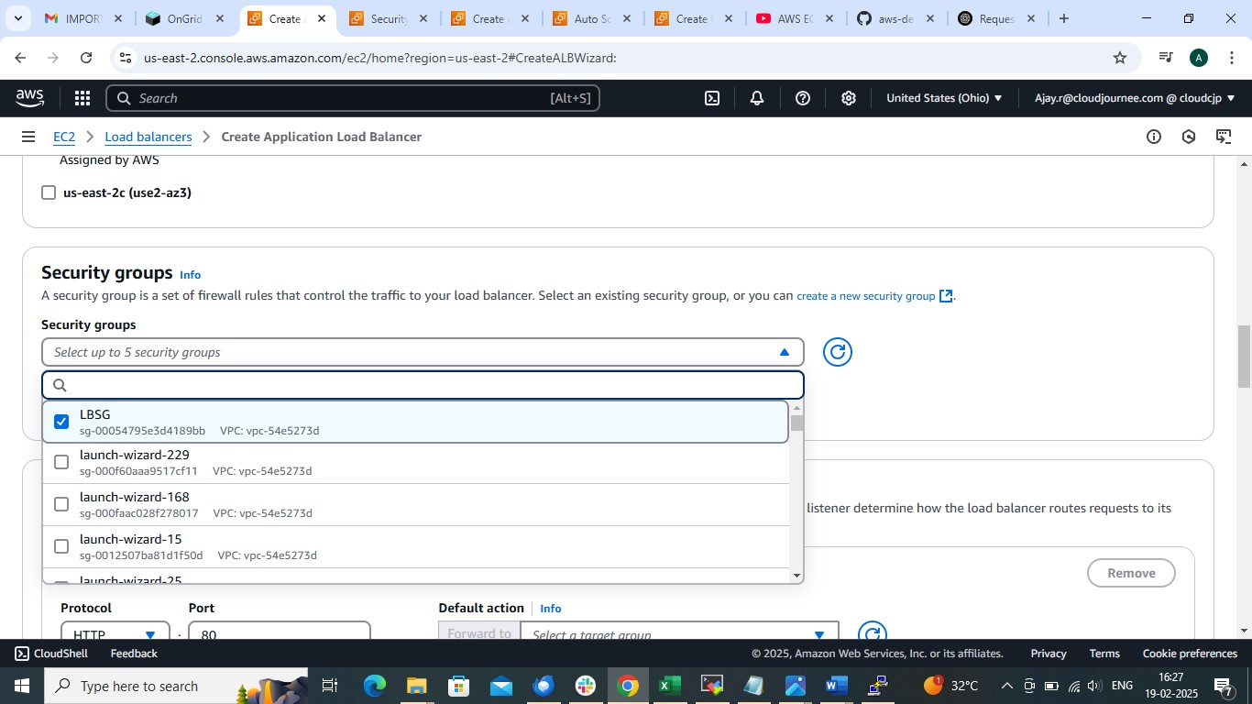

After that CREATE TARGET GROUP Add target instances as Instance

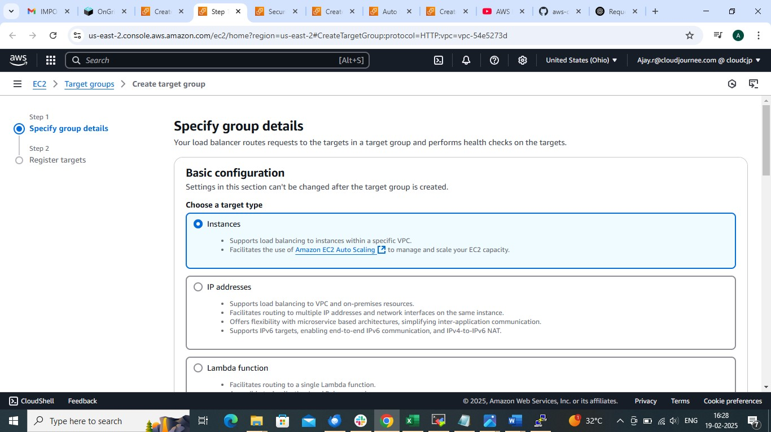

Create target Group
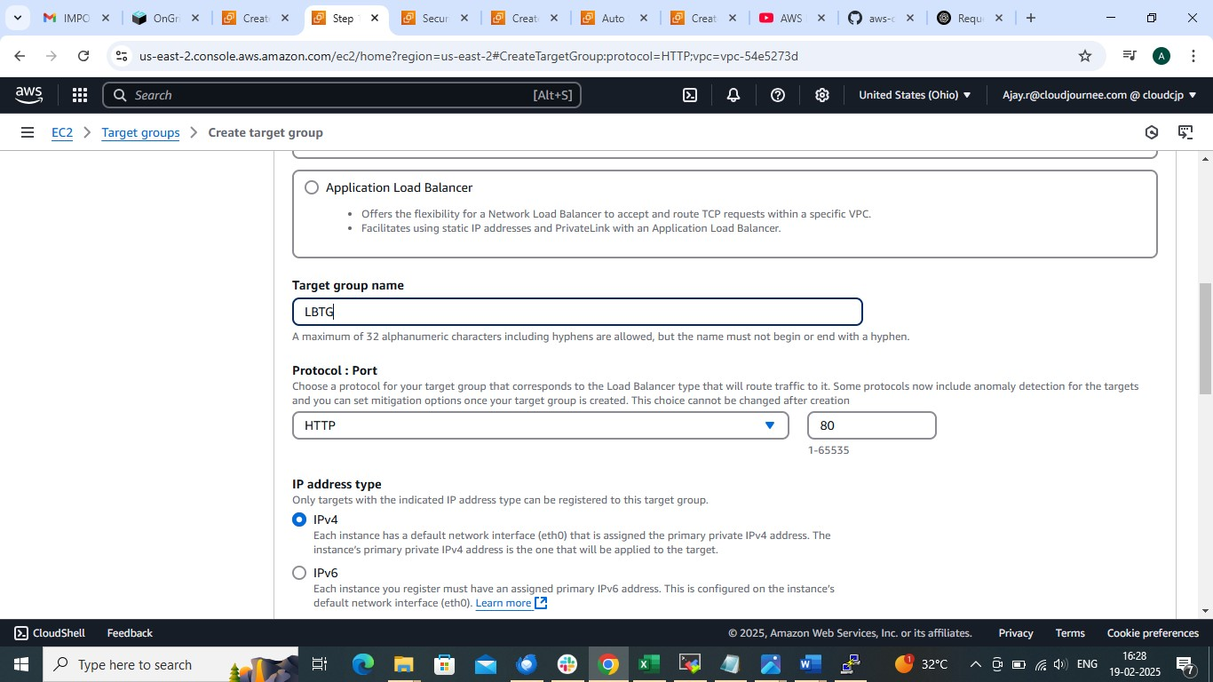

Add Target to target group
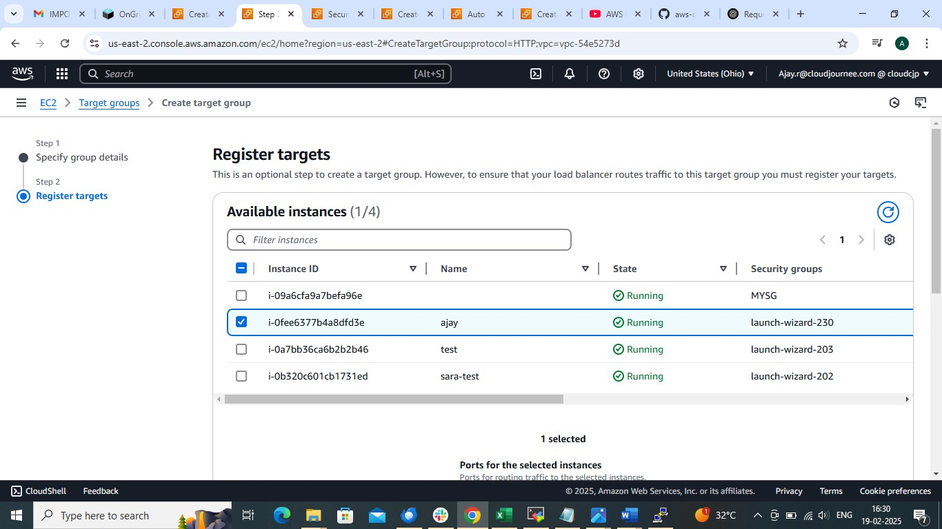

And attach target group to LB

Create LB
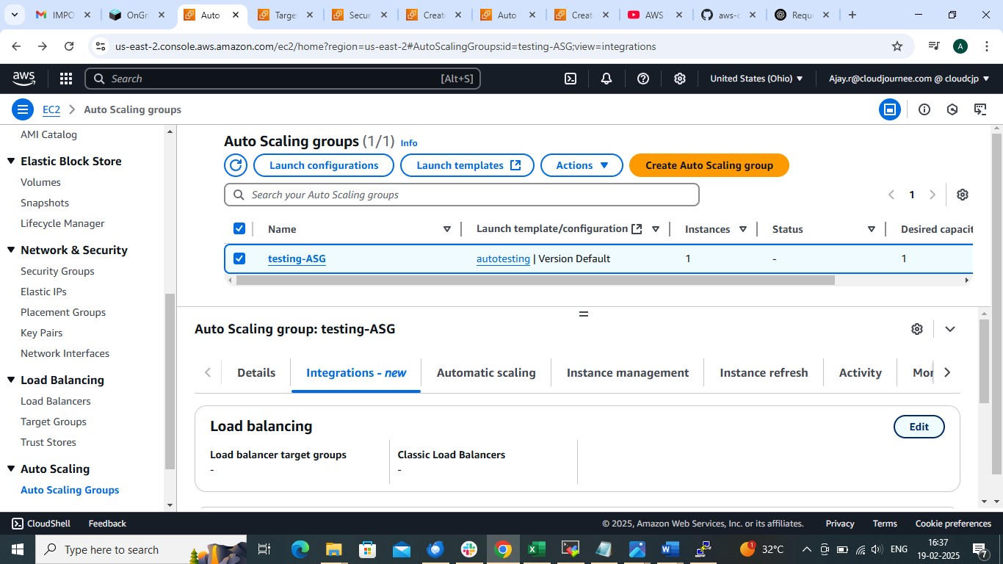

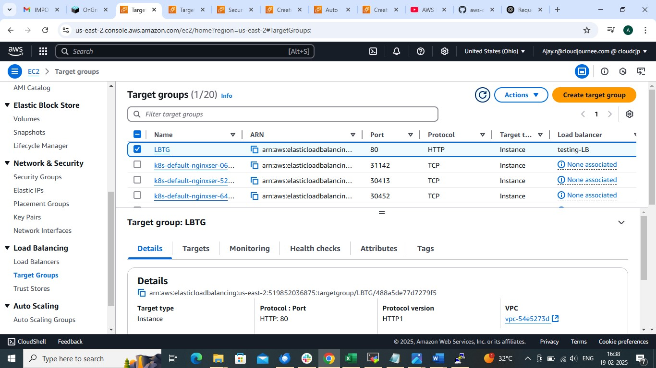

Copy and DNS name
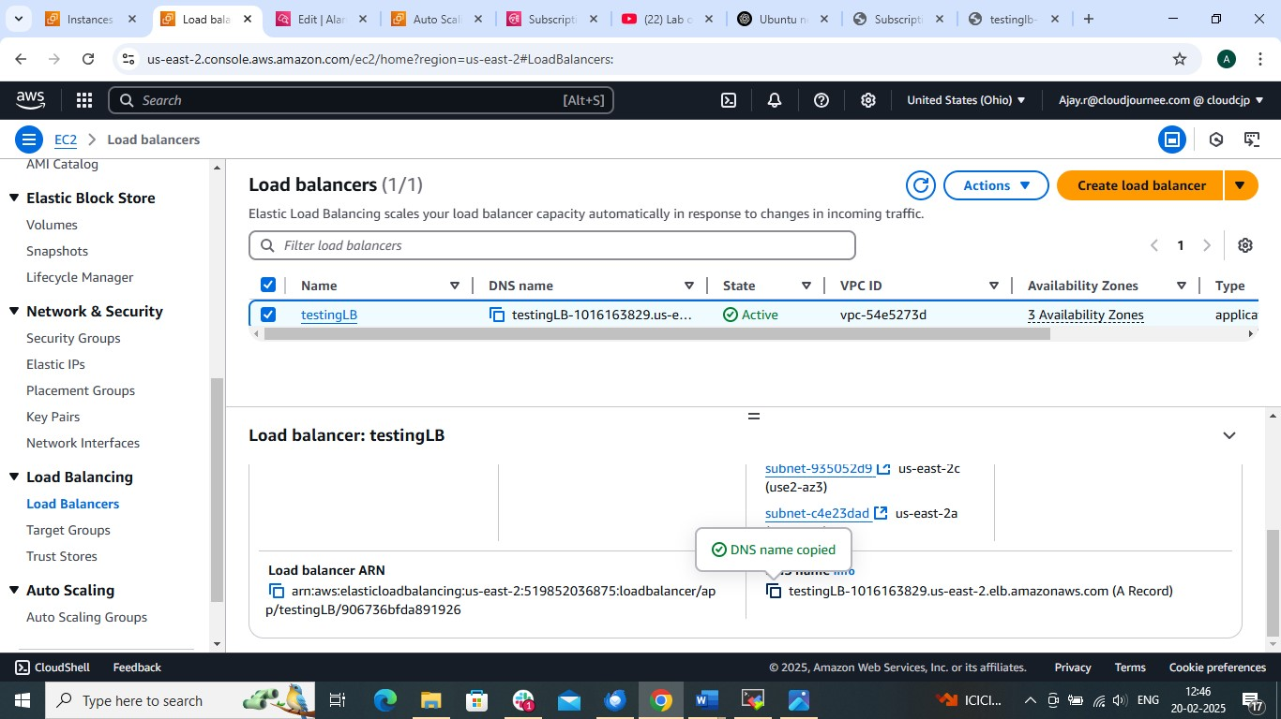

And paste it in google (MAKE SURE TO REMOVE S FROM URL PATH OF HTTPS)


